

ELB17F
Entry Level Bioinformatics
08-12 May 2017

(First 2017 run of this Course)

Basic Bioinformatics Sessions

Practical 6: Multiple Sequence Alignment

Thursday 19 October 2017
Multiple Sequence Alignment
Here we will look at some software tools to align some protein sequences. Before we can do that, we need some sequences to align. I propose we try all the human homeobox domains from the well annotated section of UniprotKB. Getting the sequences is a trifle clumsy, so concentrate now! There used to be a much easier way, but that was made redundant by foolish people intent on making the future ever more tricky!!
So, begin by going to the home of Uniprot:
http://www.uniprot.org/
Choose theoption of the button.
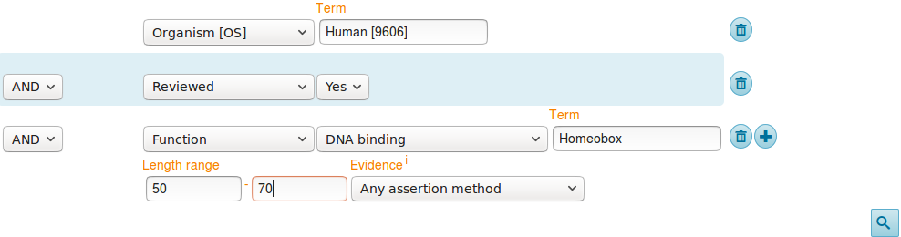
First specify that you are only interested in Human proteins. To do this, set the first field to Organism [OS] and Term to Human [9606].
Set the second field selector to Reviewed and the corresponding Term to Yes (that is, choose to find only SwissProt entries).
Click on the button to request a further field selection option. Set the new field to Function. Set the type of Function to DNA binding. Set the Term selection to Homeobox.
From previous investigations, you should be aware that a Homeobox domain is generally 60 amino acids in length. To avoid partial and/or really weird Homeobox proteins, set the Length range settings to recognise only homeoboxs between 50 and 70 amino acids long.
Leave the Evidence box as Any assertion method, one does not wish to be too fussy! Address the button with authority to get the search going.
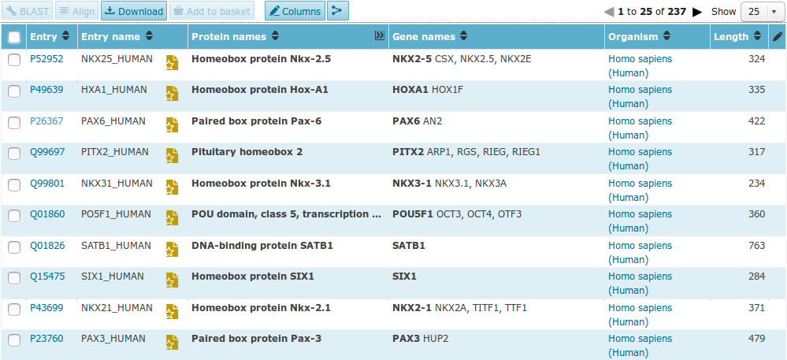
A fine miscellany of sequences will assemble upon you screen. Most seem to declare themselves in possession of a Homeobox or two (including PAX6_HUMAN), so I suggest a declaration of success.
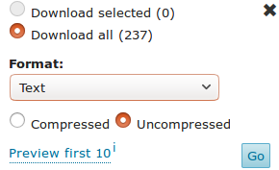
Now save the entire list into a file using thebutton. Set the download to uncompressed. Make sure you have all sequences selected and that Text (i.e. EMBL or SwissProt) format selected. Press the Go button and do whatever it takes to ensure your results end up in a file residing on your Desktop called:
human_homeobox_proteins.emb
ID NKX25_HUMAN Reviewed; 324 AA.
AC P52952; A8K3K0; B4DNB6; E9PBU6;
DT 01-OCT-1996, integrated into UniProtKB/Swiss-Prot.
DT 01-OCT-1996, sequence version 1.
DT 30-NOV-2016, entry version 177.
DE RecName: Full=Homeobox protein Nkx-2.5;
DE AltName: Full=Cardiac-specific homeobox;
DE AltName: Full=Homeobox protein CSX;
DE AltName: Full=Homeobox protein NK-2 homolog E;
GN Name=NKX2-5; Synonyms=CSX, NKX2.5, NKX2E;
OS Homo sapiens (Human).
OC Eukaryota; Metazoa; Chordata; Craniata; Vertebrata; Euteleostomi;
OC Mammalia; Eutheria; Euarchontoglires; Primates; Haplorrhini;
OC Catarrhini; Hominidae; Homo.
OX NCBI_TaxID=9606;
RN [1]
RP NUCLEOTIDE SEQUENCE [MRNA] (ISOFORM 1).
RC TISSUE=Heart;
RX PubMed=8900537;
RA Turbay D., Wechsler S.B., Blanchard K.M., Izumo S.;
RT "Molecular cloning, chromosomal mapping, and characterization of the
RT human cardiac-specific homeobox gene hCsx.";
RL Mol. Med. 2:86-96(1996).

Take a swift look at the file you have just created. Your neat list of Human Homeobox sequences will have transformed into a flood of many SwissProt format UniProtKB entries. Ugly, but what is required.

FT CHAIN 1 374 Pre-B-cell leukemia transcription factor
FT 4.
FT /FTId=PRO_0000049241.
FT DNA_BIND 210 272 Homeobox; TALE-type.
FT {ECO:0000255|PROSITE-ProRule:PRU00108}.
FT VARIANT 169 169 V -> I (in dbSNP:rs8108180).
FT /FTId=VAR_059355.
FT VARIANT 177 177 M -> V (in dbSNP:rs8108981).
FT /FTId=VAR_059356.
FT VARIANT 283 283 T -> M (in a colorectal cancer sample;
FT somatic mutation; dbSNP:rs376647012).
FT {ECO:0000269|PubMed:16959974}.
FT /FTId=VAR_036439.
FT CONFLICT 368 368 I -> T (in Ref. 1; BAG53471).
FT {ECO:0000305}.
SQ SEQUENCE 374 AA; 40854 MW; B9CE8BE93D0B7ABC CRC64;
MAAPPRPAPS PPAPRRLDTS DVLQQIMAIT DQSLDEAQAR KHALNCHRMK PALFSVLCEI
KEKTVVSIRG IQDEDPPDAQ LLRLDNMLLA EGVCRPEKRG RGGAVARAGT ATPGGCPNDN
SIEHSDYRAK LSQIRQIYHS ELEKYEQACR EFTTHVTNLL QEQSRMRPVS PKEIERMVGA
IHGKFSAIQM QLKQSTCEAV MTLRSRLLDA RRKRRNFSKQ ATEVLNEYFY SHLNNPYPSE
EAKEELARKG GLTISQVSNW FGNKRIRYKK NMGKFQEEAT IYTGKTAVDT TEVGVPGNHA
SCLSTPSSGS SGPFPLPSAG DAFLTLRTLA SLQPPPGGGC LQSQAQGSWQ GATPQPATAS
PAGDPGSINS STSN
//
Search (Control F) for the term DNA_BIND.
It should occur many times (at least once per sequence) in the Feature Tables and most often refer to a Homeobox region.
In the DNA_BIND Feature Table entries, the position of the Homeoboxs are recorded and will be used by the next program to isolate the sequence of the Homeoboxs.

Now to extract from the whole protein sequences you have saved in a file, the sequences of just the Homeobox domains. One way of doing this (possibly not the best), is to use an EMBOSS package program called extractfeat. This can be found in many places, including the Bioinformatics server at Wageningen in the Netherlands. Go to:
http://emboss.bioinformatics.nl/


Find the program extractfeat (in the EDIT section), and set it going.

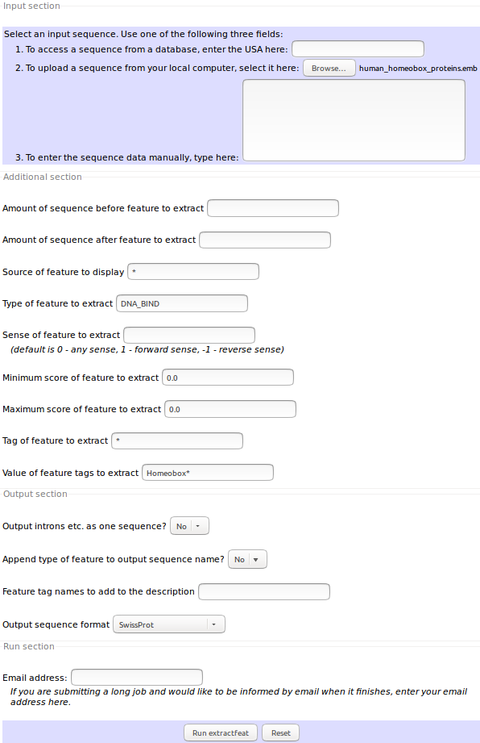
Use the Choose File button to upload the SwissProt format sequences from UniProtKB that you saved in the file:
human_homeobox_proteins.emb.
Set Type of feature to extract field to DNA_BIND (Make sure you remove the “*”).

Set Value of feature tags to extract to Homeobox* (Make sure you append the “*” to ensure hits with, for example “homeoboxes”).

Set the Output sequence format to SwissProt (Fasta would do, but SwissProt retains more annotation).

Click on thebutton to start extractfeat going. Many sequences of 60 amino acids (or so) in length will leap into view.
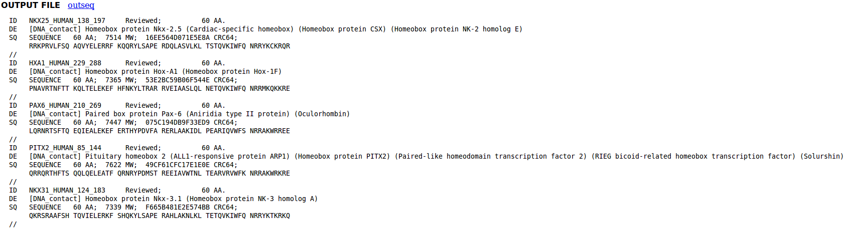
Right click thebutton and select Save Link as... . Do whatever it takes to save all your Homeobox domains into a file residing on your Desktop called:
homeobox_human.emb
Finally, we have some sequences with which to investigate the multiple sequence alignment programs.
Take a look at the file you have created. You should have many human homeobox domains in SwissProt format, looking rather as they did in your browser window. Happily ClustalX, the first multiple alignment program to be investigated, accepts multiple sequence SwissProt format files as input.
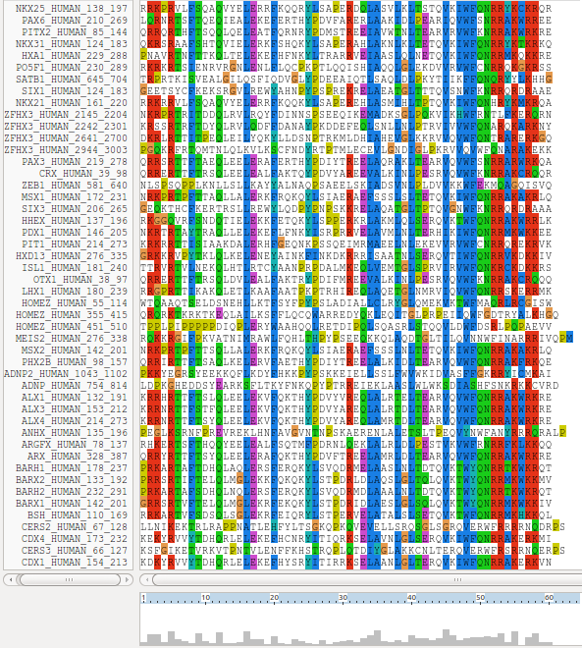
ClustalX is a part of the mostly widely known family of Multiple Sequence Alignments (MSA) programs, originating in the 1980s. Until relatively recently, it was the only real option. ClustalX still has merit, although it lacks some of the sophistication of more recent programs. ClustalX runs on effectively all workstations and has a nice Graphical User Interface (GUI). A good place for us to start. It is installed on your workstations.

Start up the program ClustalX. The ClustalX Graphical User Interface (GUI) will regally mount your screen.

Select Load Sequences from the File pull down menu and load your file of homeobox domains (homeobox_human.emb).

The sequences will arrange themselves colourfully. Many of the homeoboxes are similar enough to look convincing even before alignment. Note the “Manhattan skyline” under the sequences indicating the varying degrees of conservation.

You might like to increase the Font size from the minute default setting designed for Hawks and Eagles, to something more comfortable. 24 works tolerably well for me.


From the Alignment pull down menu, go to the Alignment parameters menu and select Pairwise Alignment Parameters. Just for a moment, change the setting from Slow-Accurate to Fast-Approximate. Bring the corresponding parameters into view by clicking on Fast/Approx Pairwise Parameters tab.
Hopefully, we will have discussed the way ClustalX (and similar multiple alignment tools) work. Intuitively, it should not make a lot of difference how the initial pairwise comparison stage is conducted. However, it very often does.
Specifically for this set of proteins, as well as generally, ClustalX will give a noticeably better alignment if the initial pairwise alignment stage is done carefully. Accordingly, reverse your whimsical setting change by moving back from Fast-Approximate to Slow-Accurate.

Click on the Slow/Accurate Pairwise Parameters tab for a final look at the default parameters to be used. The Slow-Accurate option is essentially a version of Global Alignment algorithm we will have discussed previously. Hopefully, all the parameter options will therefore be familiar to you.

I will assume both sets of parameters at least seem familiar? If not please ask. The default Slow/Accurate Pairwise Parameters you now have in view are fine. Click the OK button to dismiss the Pairwise Parameters window.


Before proceeding, save the homeobox sequences in FASTA format, which will better suit the other MSA programs we will try. Do this by selecting Save sequences as... from the File pull down menu. Deselect CLUSTAL format, select FASTA format.
Change the default file output file name to homeobox_human_full
Click OK. A file called homeobox_human_full.fasta will be created. Take a look to check it is as you would expect.

Strangely, saving your sequences in FASTA format convinces clustalx that it should now output its alignments in FASTA format. To prevent this, select Output Format Options from the Alignments pull down menu. Deselect FASTA format and select CLUSTAL format. Click OK.

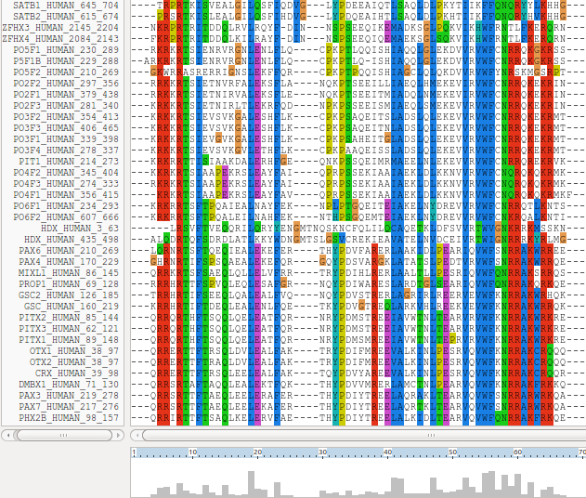
From the Alignment pull down menu, select Do Complete Alignment. Accept the default names for output files and click on the OK button. ClustalX will start to think deeply and eventually come up with it view of how the homeobox domains should be aligned.
Note the display at the bottom of the ClustalX window in which the preliminary pairwise comparisons of all sequences is monitored. The scores from these comparisons are used to compute the Guide Tree.
Not a bad first try. From an entirely non scientific, cosmetic, viewpoint, the ragged ends offend a trifle, as does the gap just before position 30!
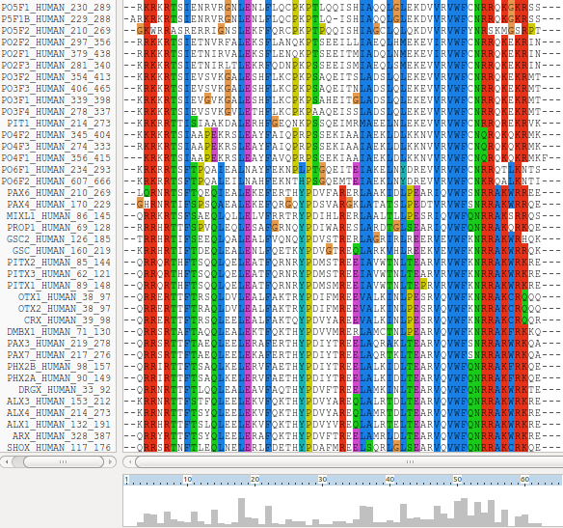
In reality, these features might be interesting, but here I go for pretty!
So, just to investigate what is possible, select all the homeobox sequences that are causing the gap around position 30 by clicking on their names (quite a lot of them I fear). Hold the Ctrl key down to allow multiple selection.
All selected, go to the Edit pull down menu and select Cut Sequences. Then select Remove Gap-Only columns from the Edit pull down menu. Nasty gap gone … along with all scientific credibility, but … never mind.
You could recompute the alignment from scratch for the reduced sequence set ending up with the same answer. Just for the sake of it, select Select All Sequences from the Edit pull down menu. Then select Remove All gaps from the Edit menu and confirm your intentions. You are now back where you started, but without the sequences that mess up the alignment intolerably!
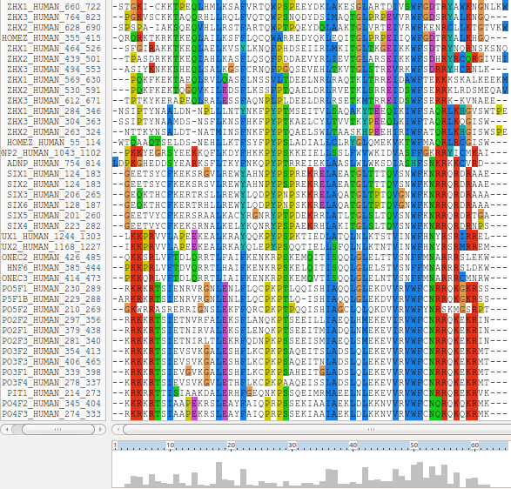
Save your filtered set of sequences. From the File menu select Save Sequences as... . Choose FASTA format only. This time, create a file with the default name:
homeobox_human.fasta
The full original set of sequences was saved in a differently named file, as a precaution. I am convinced the sequences eliminated would not align convincingly with any of the tools we have at hand. Let us lose them! Press the OK button.
From the Alignment menu, select Output Format Options and then select CLUSTAL format only.
From the Alignment menu, select Do Complete Alignment. Accept the default names for the output files. This will overwrite your previous efforts, but no matter. More deep thought. Well, I got back to where I was, no gaps around position 30 but still with ragged ends!
It is difficult to prove you have exactly the same alignment as previously as the order of the MSA will be different. This order being determined by the pairwise comparison stage of the ClustalX MSA computation.
The Prosite motif database uses Patterns to represents protein features (in addition to HMMs). The pattern for a homeobox is the ever memorable:
[LIVMFYG]-[ASLVR]-x(2)-[LIVMSTACN]-x-[LIVM]-{Y}-x(2)-{L}-[LIV]-[RKNQESTAIY]-[LIVFSTNKH]-W-[FYVC]-x-[NDQTAH]-x(5)-[RKNAIMW]
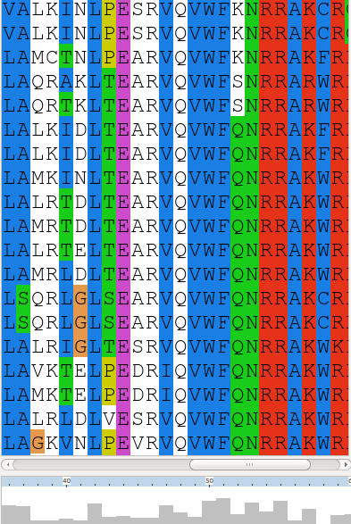
Any speculations as to how this might be interpreted? Hint?

This pattern corresponds to positions 36 to 59 in my alignment. See that the “Manhattan Skyline” is encouraging in the parts of this region that matter.
Note that the profile Tryptophan, in position 50, is very consistent, but not quite 100% as suggested by the Prosite pattern. The W was even conserved in the sequences that were cosmetically removed.
Position 52 is not conserved (“-x-”) according to the Prosite pattern. In the alignment segment offered here, it looks like a pretty consistent Q. However, the “Manhattan skyline” at this position is quite low, suggesting that the sequences in view might not be typical of the whole alignment set. Which, upon checking …. they are not!
Looking through this alignment, I get the feeling I could design a better, stricter pattern for the region between 36 and 59. Possibly true, but remember the pattern in Prosite aims to represent the conservation of Homeobox domains in ALL organisms. Here we have only sequences from Human.
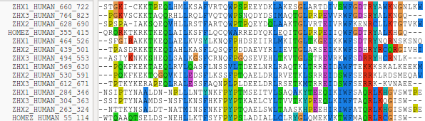
Of course, things are not quite so convincing throughout. If you look at the top and bottom few sequences, you will see that ClustalX had its moments of uncertainty.
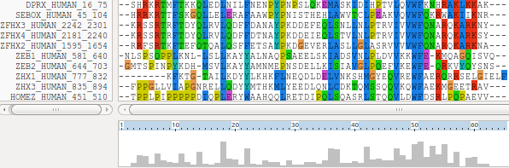

Note, however, the consistent W in position 50 despite the surrounding crumble.
Now to show existence of some msa program options available on the web. There are many. They are available from a number of server sites. An obvious place to start has to be the EBI page dedicated to MSA. Go to:
http://www.ebi.ac.uk/Tools/msa/
Offered here is a selection of popular, current generation MSA tools. Each is accompanied by advice to guide the choice of tool to best fit the circumstances. Each tool is provided with a link to its Launch interface. All the Launch interfaces are very consistent. Once you have run one of the MSA options, you should have no trouble running any of the others.
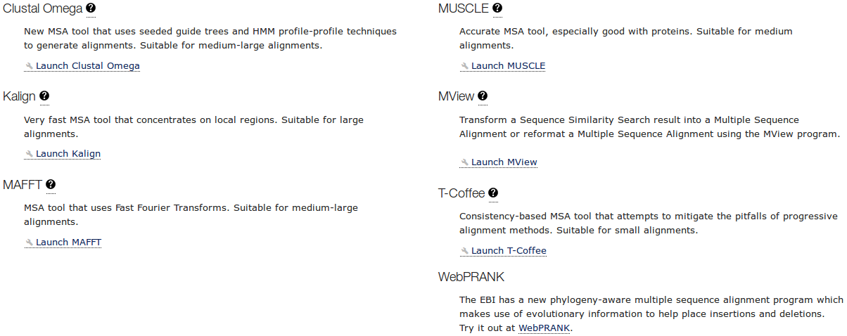
Here I intend to align again the human homeboxes with just one of the tools on offer. Then take a quick look at how the machine generated multiple alignment can be manually edited using Jalview, a program that is probably installed on your workstation and definitely available as a web service. You might have already used Jalview as an alignment viewer when investigating Pfam and/or Jpred.
Then I will invite you to try a few of the other options for yourself and see that they do not all produce the same alignment! Differences reflect not only the parameters selected, which we will have discussed, but also the particular objectives of the program selected. For example, a multiple protein sequence alignment optimal for investigating conservation of protein structure might well not be identical to one best representing protein evolution.
Used to align the Homeobox sequences used in this exercise, I do not expect you will see much difference between the outputs of any of these options. They will all work sufficiently on such a simple data set.
The program whose use I choose to describe carefully, leading on to a short Jalview exercise is MUSCLE. I choose thus as MUSCLE is now the first choice of most of the people with whom I work. Also popular are Clustal Omega, MAFFT and, for phylogeny, WebPRANK.

So the plan now is to use MUSCLE to align again the homeobox sequences previously aligned with ClustalX. MUSCLE works in a way similar to clustalX but it takes rather more care in the generation of the Guide Tree used to control the order of pairwise construction of the final multiple alignment. Particularly for more difficult alignments, MUSCLE should do a better job than ClustalX. The alignment you will generate here will certainly be different. I leave you to judge for yourselves whether it is better.

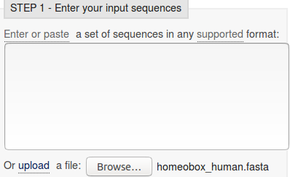
Start by requesting to.
Use thebutton to upload the file containing the FASTA format homeobox sequences, homeobox_human.fasta. This file should not included the sequences with a mess around position 30.

Take a look at the Set your Parameters section of the page. I find the claim that “The default settings will fulfill the needs of most users and, for that reason, are not visible” a little strange? What about the users who are not in the category “most”? I want control over all the programs that their creators deemed sensible to make available?


The default settings behind thebutton are not those that affect the computation of the MSA. I confess myself confused at the lack of any meaningful options to consider? I was expecting at least the gap open and gap extension penalty options (available elsewhere, including Wageningen), plus a way to change the scoring matrix. I have inquired why things are as they are (most recently 2016.04.17). No practical issue here, as I intended to suggest the defaults whatever they were. Look at the range of settings for the OUTPUT TREE parameter. none is indeed the thinking persons choice, but … one or the other (but not both?) of the Guide Trees that MUSCLE will compute can be saved if you wish. You may also set the OUTPUT ORDER to aligned or … aligned?


There are a number of OUTPUT FORMATS offered. For a quick glance at your results, both ClustalW or HTML are fine. Here I suggest it would be nice to generate an output that can be downloaded and viewed in Jalview. The default ClustalW or Pearson/FASTA serve for this purpose. As ClustalW looks more like an alignment in the web page, I choose ClustalW.

How do the options for the OUTPUT TREE relate to the output files of ClustalX and the difference between the way that ClustalX and muscle work?

Comment on how one might choose between the range of options offered for the aligned parameter?

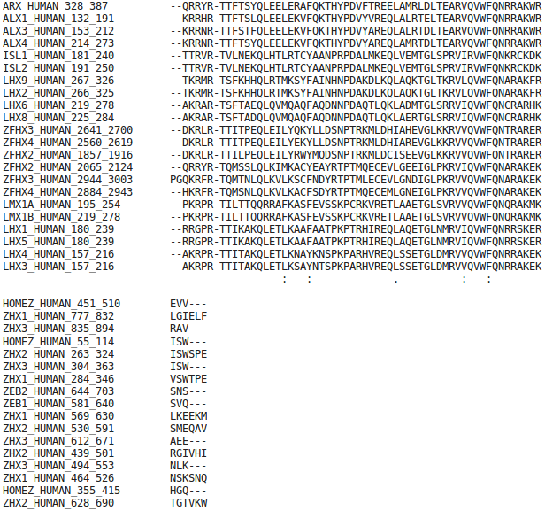

After considering these enigmas, or before if you prefer, Click on thebutton and sit back to admire muscle in action.

The alignment that is computed is, superficially at least, similar to that offered by ClustalX.

The alignment is irritatingly split into two sections. A nice extra parameter might have been “How wide would you like your alignment to be”? A problem with the format rather than the program, to be fair.

At the very bottom of the page, muscle whines:
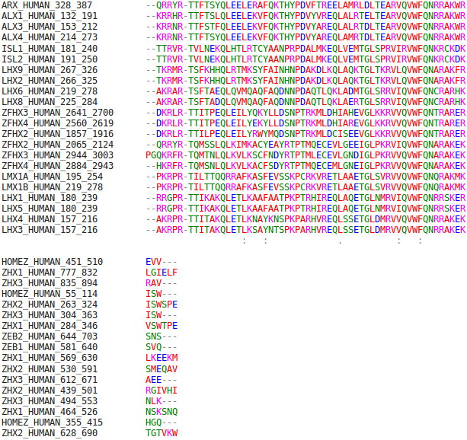

So click the Show Colors button at the top of the page and try to live with the pain of such gross Trans-Atlantic inept spelling in a European site!!! Good Grief! They get everywhere!!

Well, an improvement I suppose? Colours are very useful (even slow ones) in the interpretation of alignments. Various colour schemes are used to clarify the message of alignments. Colouring can indicate shared amino acid properties not immediately evident when the letter representations differ.

But any decoration available here is far short of what can be achieved with Jalview, so click on the Download Alignment File button to save you alignment in a file on your Desktop called:
homeobox_human_muscle.aln
Jalview can be easily installed under all commonly used operating systems and run locally. For these exercises, I attempt to use services available freely from the INTERNET wherever possible, so let us run Jalview from the web here by first going to:
http://www.jalview.org/
and selecting thelink at the top of the page. And agree with all the many questions you will be asked.
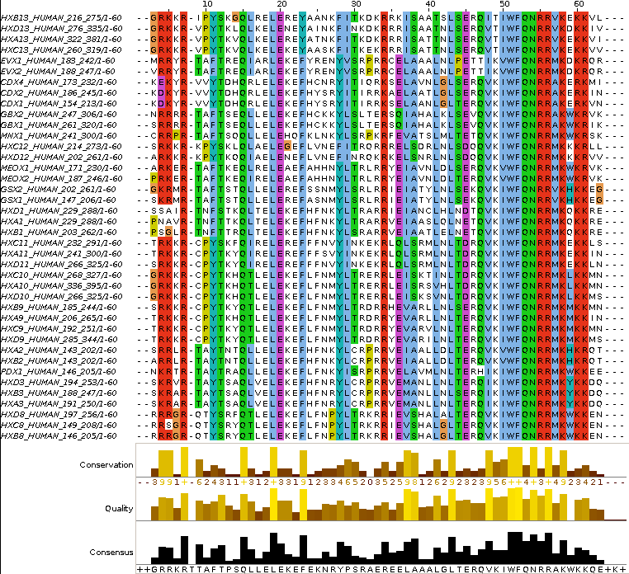
Close down all the example outputs Jalview sees fit to show you on start up. From the File pull down menu choose from File from the Input Alignment option. Locate and load the file:
homeobox_human_muscle.aln
You might need to adjust the file name filter to included .aln files.
The default view is a trifle bland. Try a few of the options from the Colour pull down menu.
You could try the default colour scheme used by ClustalX, for example.
The MUSCLE and massaged ClustalX alignments now look very similar! In the nicely aligned regions at least.
There are many Jalview features that merit investigation. Have a look around if you have time. In particular, Jalview will compute simple phylogenetic trees for you employing a number of methods (Calculate Tree from the Calculate pull down menu). Try it, but be aware this is only sensible if you were very sure of your alignment (and have more meaningfully selected sequences maybe?).
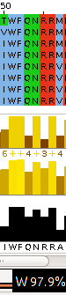
Jalview is made by the same group as produce Jpred (an extremely effective Secondary Structure Prediction system). You could send your alignment for Secondary Structure Prediction via the Web Service pull down menu, if you wished.
A central purpose of Jalview is to allow users to edit alignments as well as just to view them. For example, hold down the Shift key, click and hold on any amino acid at the edge of a gap, slide left and right and see that you can introduce and/or alter the position of gaps. It is very important to be able to edit alignments generated by even the best of programs. As I hope has been made clear, the alignment algorithms are crude. If you know something about the sequences you are aligning it is very reasonable to suppose you can improve upon the computer's alignments. Jalview tries to make this possibility easy. Look through some of the other Edit pull down menu options, maybe to increase the font size in particular!, it does not matter how much you mangle your alignment, you can always make another one.
Finally, take a look at the Jalview “Manhattan Skyline” for the highly conserved W at position 51. This seems better quality than clustalX managed? I am not sure how one can make further comment without knowing what parameters were used. Is there really an improvement? If so, is it due to the improved algorithm or more appropriate choice of parameters? Impossible to discuss further as the parameters used for MUSCLE are not revealed.
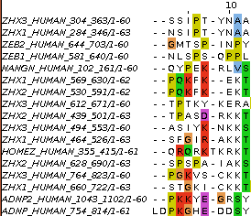

In my alignment, the W at position 51 was at position 50, according to clustalx. This slippage to the right is due to MUSCLE introducing an extra gap, inspired by just one sequence at position 8. Is this sensible? No idea … exactly when it might be good idea to investigate the effect of lighter/heavier gap penalties?

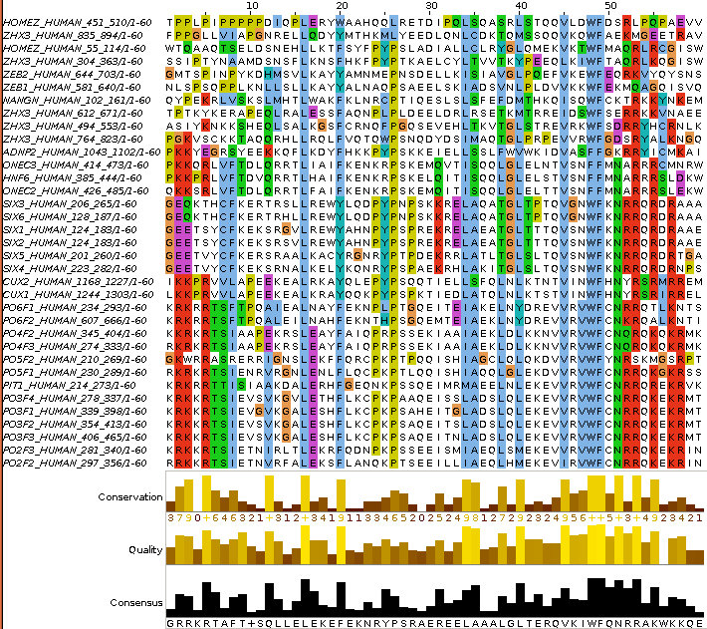
You can also Select and Cut sequences in a way similar to that you employed with clustalx. I could not resist it! I removed all the ugly sequences that caused the gaps at the start and finish of the alignment, and the sequence that messed up column 8 (just select their names and then select Cut or Delete from the Edit menu). I achieved the gap-free beautiful alignment illustrated.
Of course, Jalview does not compute alignments, so once I had removed all the unfortunate proteins, I had to use an Edit option to tidy up my meddling. I used Remove Empty Columns to get rid of the gap columns at the start of the alignment. The gaps at the end just melted away once the sequences that supported their presence were removed.
Science is easy! Once you remove the need for honesty that is.
If it could be done slightly more meaningfully, I would suggest you might try some of the other MSA tools offered by the EBI, to investigate the differences in the alignments computed. Any differences might be due to different parameter selection or differences in the algorithms of the tool you select.
For full control, you really need to download the various tools and run them locally. The EBI is not the only site that hides significant parameters from their users.
PSI-BLAST
This program is used to find a comprehensive set of relatives of a protein. First, BLAST is used to find closely related proteins. From an alignment of these proteins a general "profile" (a Position Specific Scoring Matrix - PSSM) is computed. A PSSM is very similar in concept and purpose to an HMM profile in that it summarises significant features present in the sequences it represents.
A further search of the protein database is then run using the PSSM as a query, and a larger more widely associated group of proteins is found. This larger group is aligned and used to construct another PSSM, and the process is repeated until no more significantly matching new sequences can be detected, or the user tires of the whole process.
PSI-BLAST is integrated into the Secondary Structure Prediction system Jpred. Whenever Jpred is asked to compute structure form a single protein sequence, it will use PSI-BLAST to construct an aligned family of protein sequences to enable an improved prediction. An aligned family of proteins is a much better starting point than any single protein sequence.
Similar ideas are used by the domain database PFAM to create large alignments of domain regions.
Here we will use PSI-BLAST directly from the NCBI on the Paired DOMAIN of the PAX6 protein that you saved in a file earlier. It should be possible to detect a large family of PAX domains and to eventually multiply align them generating something like the alignment from the PFAM database.
To investigate PSI-BLAST go first to the NCBI Home page at:
http://www.ncbi.nlm.nih.gov/
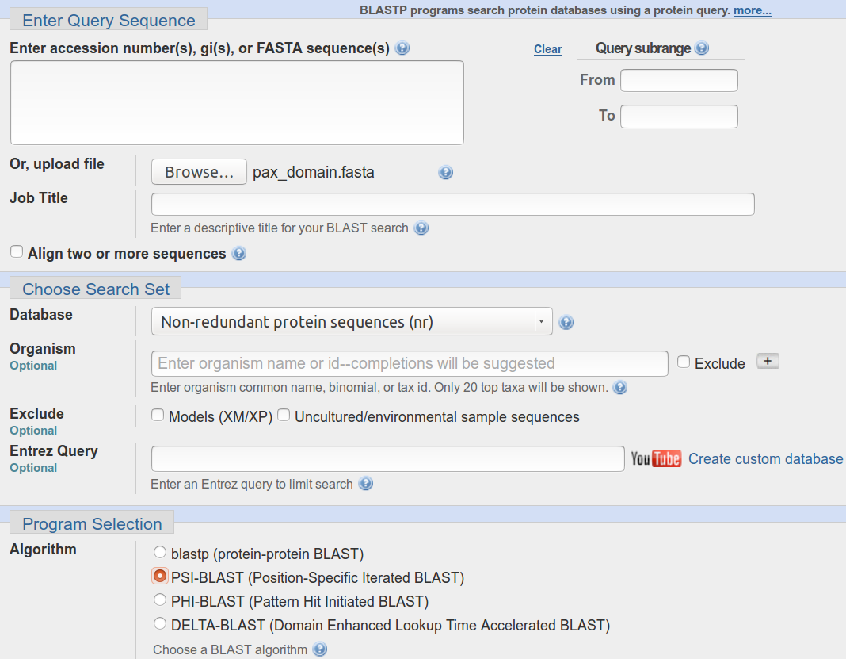
Click on the BLAST option from the Popular Resources menu.
Selectfrom the Web BLAST section.
Upload the PAX6 paired box domain sequence (stored in the file pax_domain.fasta) using the appropriate Browse button.
Select PSI-BLAST from the Program Selection section. Leave all the others options at their default settings, particularly the option to search all the proteins available.
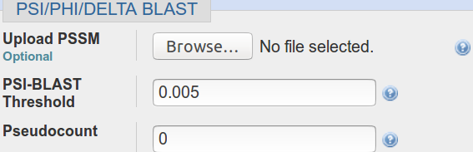
Before you set PSI-BLAST going, click on the Algorithm parameters link and take a look at the PSI/PHI/DELTA BLAST section. Note the option to use a PSSM from a previous run of PSI-BLAST, potentially on a different database (but with the same query sequence). Accept the default that database entries scoring better than an Expect Threshold of 0.005 be offered for inclusion into the PSSM of each successive PSI-BLAST iteration. Remember thebuttons.
What do you suppose the choice of Pseudocount might influence?
Elect to Show results in a new window and then click on the button.
After several moments of deep thought, PSI-BLAST will come back with its first set of results, at the top of which is a report that (unsurprisingly) matches have been detected between the query sequence and several domain databases.
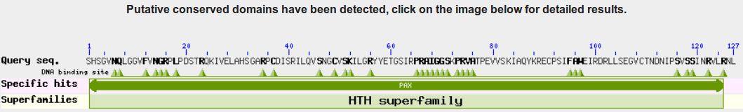
For more detail, click on the Conserved Domains graphic.
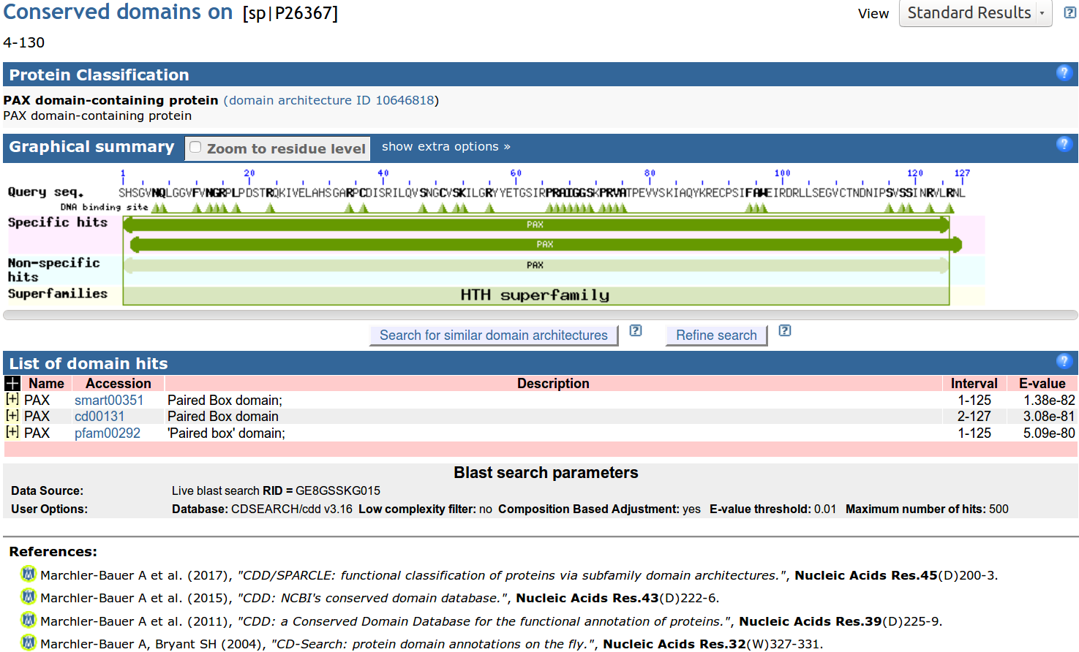
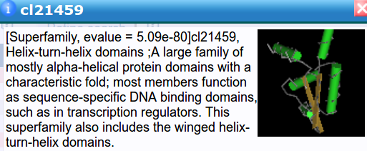
Hover over the Specific / Non-specific hits and you will see that SMART, Pfam and the NCBI Conserved Domains database matches for a PAX domain are all reported. No surprise here.
There is also a Superfamilies (derived from SCOP as briefly mentioned previously) hit recognising that a PAX domain, in common with many other domains, includes Helix-Turn-Helices.
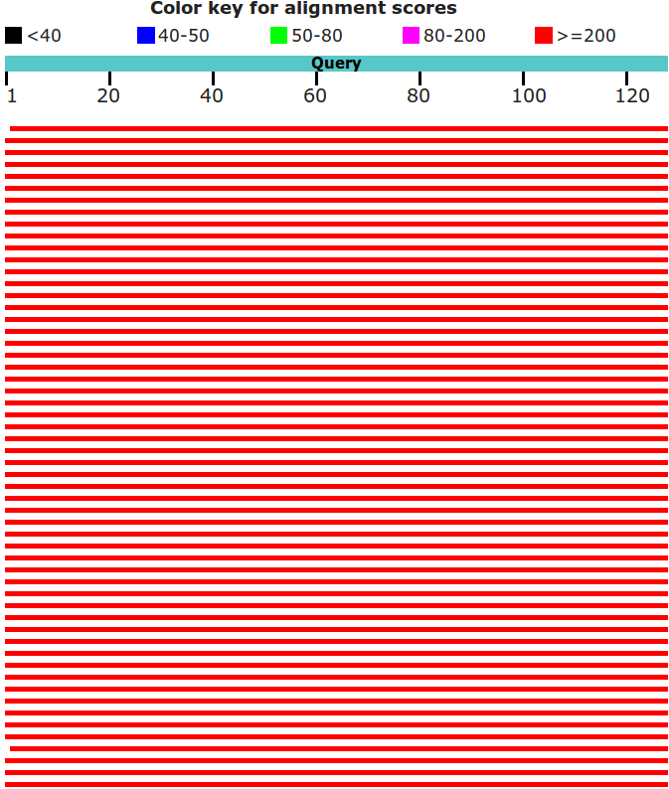

Moving back to the main PSI-BLAST results, you will see that there are many high quality hits covering the whole length of the query sequence.

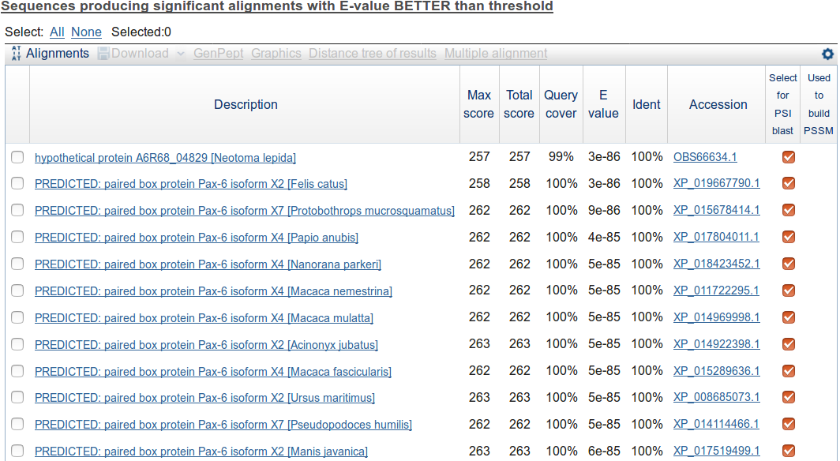
The best 500 of these are listed.
All the listed hits are selected for inclusion into the PSSM for the next iteration. Unless you feel strongly about any particular entry, leave them all selected.
Note the Accession Codes that begin XP_. As mention previously, these are less well evidenced ptotein sequences from the NCBI databases.
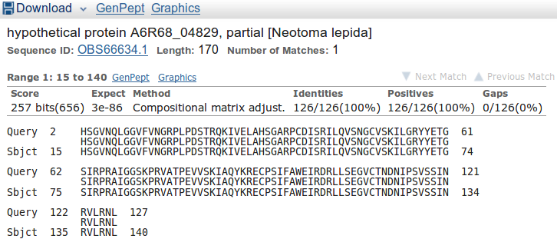
Move down to the Alignments section of the results and you will see that many of the top hits match the query exactly.
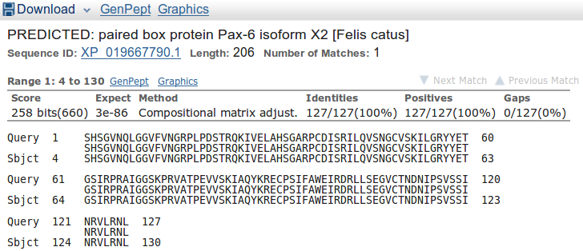
Note that many of the top hits come from the GenPept database (roughly equivalent to the TrEMBL section of UniProtKB).
How might the inclusion of poor quality and duplicated sequences have been minimised?

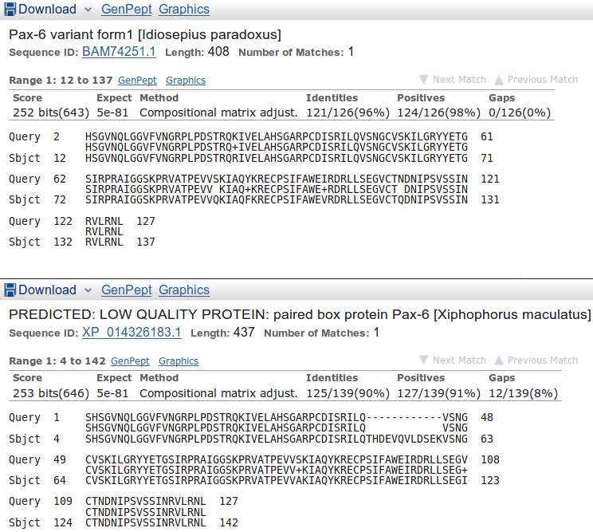

Move down far enough and you will see less perfect matches, some of which involve proteins with the extra 14 amino acids of isoform 5a of PAX6_HUMAN.

Having browsed your results sufficiently, click on the button to Run PSI-Blast iteration 2. It is at the bottom of the hit list.
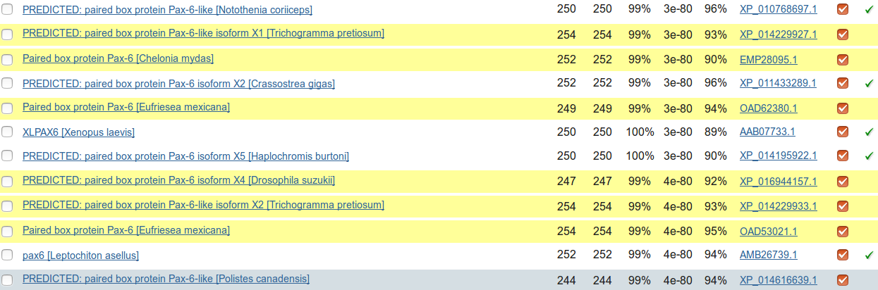
After a few moments, PSI-BLAST will return with the results of searching through the database again using the PSSM derived from the hits of the first iteration(ed). This time the top of the list will be predominantly filled with hits that have already been incorporated into the PSI-BLAST PSSM. However, look far enough down the list and you will find some new ones, highlighted yellow.
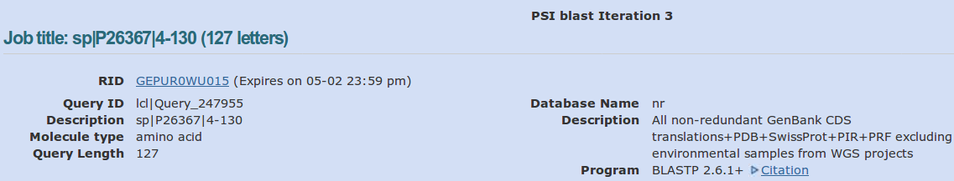
Once more, click on the button to Run PSI-Blast iteration 3. That is probably enough! As dear Eddie oft advised, there are typically but three steps to ultimate fulfilment. Recently I took just 8 iterations before there were no more new sequences suggested for inclusion into the PSMM. Recently, I was not so lucky, I got to iteration 21 before I realised that PSI-Blast was playing tricks one me! I was oscillating between two minutely different, perfectly acceptable solutions! Having vented my spleen in shame filled fashion I accepted iteration 21. I advise that you stop here on “good enough” iteration 3, as I will do this time!
Next, move to the just above the Graphic Summary and click on the Multiple alignment link. You have elected to use the NCBI multiple alignment program Cobalt to align the PAX domain sequences of your final PSI-BLAST iteration.
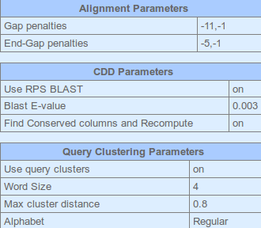
This can take quite a while. Cobalt might even complain wearily and give up occasionally. If it does, tell it not to be silly!! It will get there eventually. When it is done, click on the Alignment parameters link at the top of the results.
Cobalt reports the parameters it used to make the alignment. It is possible to recompute the alignment with different parameters by using the Edit and Resubmit link at the top of the page and then choosing to set Advanced parameters. But, maybe not today?
Recording the parameters chosen for any computation is surely extremely important. How else can published computer generated results be reproducible? Feel free to disagree, but I feel strongly this is a point not sufficiently appreciated by software engineers in this field and often entirely ignored by service providers (e.g. the “we have chosen the best parameter settings for you and feel you do not need to even know what they are” approach for the EBI MSA options).
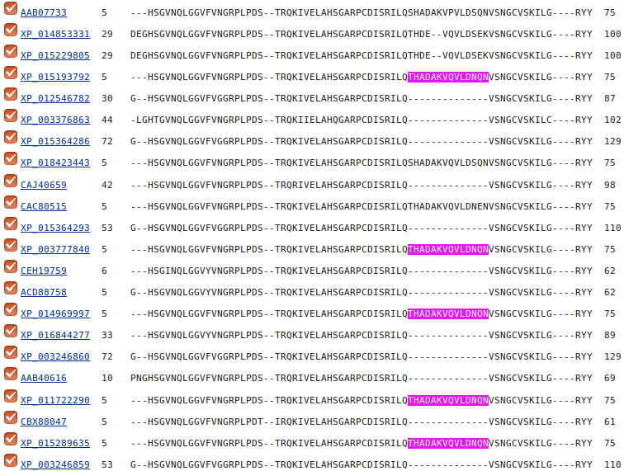
Move past the long list of aligned proteins (the easiest way is to hide the Descriptions view).
At the top of the actual alignment, set View Format to Plain Text (…. and then hide the Descriptions again??), this being the easiest format to understand in a hurry. This might take a while also. I am not sure why? Be patient, it will get therein the end. The alignment will have very ragged ends, but the important region of 120 or so amino acids representing the PAX domain is really quite impressive. In particular, the isoform 5a insertion is very convincing.
DPJ – 2017.05.01
Model Answers to Questions in the Instructions Text.
Notes:
For the most part, these “Model Answers” just provide the reactions/solutions I hoped you would work out for yourselves. However, sometime I have tried to offer a bit moer back ground and material for thought? Occasionally, I have rambled off into some rather self indulgent investigations that even I would not want to try and justify as pertenent to the objective of these exercises. I like to keep these meanders, as they help and entertain me, but I wish to warn you to only take regard of them if you are feeling particularly strong and have time to burn. Certainly not a good idea to indulge here during a time constrained course event!
Where things have got extreme, I am going to make two versions of the answer. One starting:
Summary:
Which has the answer with only a reasonably digestible volume of deep thought. Read this one.
The other will start:
Full Answer:
Beware of entering here! I do not hold back. Nothing complicated, but it will be long and full of pedantry.
This makes the Model answers section very big. BUT, it is not intended for printing or for reading serially, so I submit, being long and wordy does not matter. Feel free to disagree.
From your investigations of Multiple Sequence Alignment
How do the options for the OUTPUT TREE relate to the output files of ClustalX and the difference between the way that ClustalX and muscle work?
I leave this question here in the hope that one day I will be able to offer a full and sensible answer. First draft answer below.
Essentially, both ClustalX and MUSCLE work in two stages. First they create Guide Tree(s). Then they create a multiple alignment by pairwise steps ordered by most refined the Guide Tree.
ClustalX just computes one based exclusively on the pairwise comparison of its input sequence set.
MUSCLE will create a Guide Tree that is the rough equivalent of that computed by ClustalX. Then it will offer to refine this Guide Tree from computed draft MSAs until a user selected maximum number of iterations is met or no further improvement is possible.
ClustalX saves the Guide Tree it computes by default. MUSCLE offers to save its Guide Tree from its first or second refinement iteration.
The purpose of saving the Guide Tree(s) to a file is to enable a rerun of the second phase with new parameter settings without having to first recalculate the Guide Tree. Of course, as mentioned previously, utterly pointless if there is no way to change the parameters to allow a guide tree to be used as input? but that is the theory.
More investigation by me and expansion of this answer required. Discussion with EBI current (2016.04.20).
Comment on how one might choose between the range of options offered for the aligned parameter?
I cannot … beyond suggesting it simply does not make sense? Going by what is offered at Wageningen, the choice should be between aligned and input order. i.e. the order of the original set of sequences to be aligned or the order after they have all been compared with each other and arranged into a Guide Tree … or two.
Currently, the only way of which I am aware to run muscle with full flexibility, is to download it. It is available for Windows, Linux or Mac operating systems but has no pretty GUI front end. You have to read the manual carefully and run from the command line.
To attempt (with pain) to be fair, one might suggest that web services are for creating draft results primarily. If one wanted to get serious and have full controll over the software and record properly all the settings one has chosen, it would make sense to download the software and run in locally.
That still does not excuse offering selections that only have one option and/or save files that cannot serve any fucntion. I think I give up trying to persuade the EBI guys of this and just live with “what is”. So much more restful (2017.05.01).
From your investigations of PSI-Blast
What do you suppose the choice of Pseudocount might influence?

I clicked with confidences upon the link to the help. It opined as illustrated.
I suppose the next step is to read PMID 19088134? There is most certainly no elucidation amongst the strangle of words offered here?
The article Abstract says:
“Position specific score matrices (PSSMs) are derived from multiple sequence alignments to aid in the recognition of distant protein sequence relationships. The PSI-BLAST protein database search program derives the column scores of its PSSMs with the aid of pseudocounts, added to the observed amino acid counts in a multiple alignment column. In the absence of theory, the number of pseudocounts used has been a completely empirical parameter. This article argues that the minimum description length principle can motivate the choice of this parameter. Specifically, for realistic alignments, the principle supports the practice of using a number of pseudocounts essentially independent of alignment size. However, it also implies that more highly conserved columns should use fewer pseudocounts, increasing the inter-column contrast of the implied PSSMs. A new method for calculating pseudocounts that significantly improves PSI-BLAST's; retrieval accuracy is now employed by default.”
The article itself, continues in like vein ….. how about we close our eyes and accept the defaults? I would just wonder why the whole thing does not commence with, at least an attempt, to answer the question in the forefront of my inquiry, which is .. “WHAT, in the current context, IS a pseudocount?”. I do not believe it is as tricky as they appear to wish us to believe. I will try again later, when my view of the world is less storm infested.
In the meantime I will take comfort in the claim that:
“A new method for calculating pseudocounts that significantly improves PSI-BLAST's; retrieval accuracy is now employed by default.”
Jolly good!
2016.12.04: Aha! Wikipedia to the rescues once more. Maybe I will donate again? Wonderful service.
One can forgive the NCBI people for not explaining what a pseudocount is, as they did not, as I first thought, invent the term. It is an idea/strategy of far wider and general application as wikipedia explains.
My interpretation of this article (feel free to disagree/correct) in the current context is:
PSSMs are computed from the amino acid composition of regions of a protein sequence. Their purpose is to identify other protein regions of the same size that might be homologous. If a given amino acid is not represented at all in the region from which the PSSM is computed, the probability of any other region including that missing amino acid will be consider to be 0 (i.e. impossible!) even if the rest of the region matches extremely well.
Generally speaking, that would be a nonsense! Solution? Add a tiny bit (a pseudocount even) to all amino acid counts that come to 0. Then “impossible” becomes “extremely unlikely”, which makes a bit more sense. A trifle more poetry than science here, but I think I follow the logic.
A popular way of implementing pseudocounts is due to Pierre-Simon Laplace. A French chap who was pretty famous for having good ideas. His strategy, nattily known as Laplace's Rule of Succession, was to add a psuedocount of 1 to ALL the real counts and so pervert the message of the data uniformly. Nice one Pierre.
I am not entirely sure why, but this all reminds me of one of the many dubious culinary practices of my dear mother (when not in the kitchen, an unsurpassed example of the human female condition!). To-whit, when confronted with a spice or condiment with which she was unfamiliar, she would avoid the unacceptable zero condition by adding a swift pseudocount (sometimes two!) into whatever she was brewing at the time. The principle being that of “just in case” and the avoidance of the horror filled possibilities of “missing an exciting new flavour”.
She used to protect the family from any ill effects by assiduously, testing the psuedocount side effects upon its most dispensable member … the youngest son, say? If he still frisked after a given period, she would let loose the potion upon the rest of the family. Happily, I survive! But repeated pseudocount experimentations may well explain much of the condition of what remains.
How might the inclusion of poor quality and duplicated sequences have been minimised?
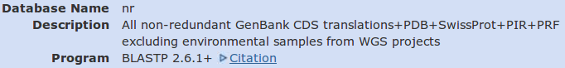
At the top of your output is recorded some details of the conditions under which you database search was undertaken. This is a very important step towards making your results reproducible. Not sufficient I would opine. Surely the database versions and a complete record of the parameters used by blast are required in order to be able to exactly reproduce a search?
But at least the version of blast and the databases that were searched are recorded. The collection of databases searched is rather optimistically called “nr”, for non-redundant. A bit of an exaggeration I would think. Surely PDB and SwissProt overlap a trifle? But let us not be too picky, in fact, surely a noble attempt to remove duplication between these databases has been made, understandably, imperfectly.
The collection of databases that is nr includes “All non-redundant GenBank CDS translations” (aka GenPept) which, like it European broad equivalent TrEMBL, includes some pretty dubious sequences.
I would think that if one wanted to maximise quality and minimise duplication, it would be best to pick just one good quality database. SwissProt is the obvious choice. blast, in general, and PSI-BLAST in particular, allows such a selection.
However, today the objective is not refinement!!! Bloat is good! More the merrier! Never mind the quality, just admire the volume.

DPJ – 2017.05.01

Of course, you could run Clustal from websites all over the world if you wished. Specifically, it is available at the Bioinformatics server at Wageningen. Try it if you have time. You get the same results but will, sadly, lose the pretty interface. http://www.bioinformatics.nl/tools/clustalw.html The EBI no longer offer basic Clustal.
The Fast-Approximate algorithm is essential that which the database searching program fasta employs. Assuming we have discussed how fasta (or blast) works, it should require little further explanation here.
From the “Manhattan Skyline”, you can see the conservation is less than 100%. Less conserved than the F that immediately follows in fact? Look at your alignment, the “Manhattan Skyline” does not seem to reflect reality? The W is very well conserved, although the scoring matrices would regard any deviation from W as serious? I need to find out more about how the Skyline is computed.
More available from a variety of websites in addition to the EBI, including the Bioinformatics server at Wageningen: http://www.bioinformatics.nl/tools/muscle.html
As discussed, superficially at least, previously. I hope.
I have asked the EBI about their policy (the same for all the locally provided MSA options). Discussion is ongoing (2016.04.20).
A useful option if you thought it possible you might want to rerun MUSCLE with different parameter setting for the stages after the Guide Tree(s) are generated. The same possibilities exist for ClustalX. Of course, utterly pointless if it is impossible to control the relevant parameters …. so I really cannot see the point of any of the More options section? I am open to elucidation from all/any sources.
A widely used java alignment editor and viewer.
But feel free to try the others. HTML is the default at Wageningen. The Phylip formats are the best if you are going to analyse your output further with the phylogeny programs of the PHYLIP package.

